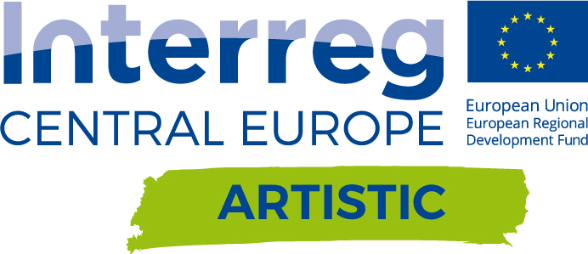

Project ARTISTIC officially launched in Treviso, Italy
27representatives of 12 partner institutions hosted by the Lead partner, the t2i Technology Transfer and Innovation gathered on the first partnership meeting held in Treviso, Italy on 26-27 of September, 2017 to officially launch the ARTISTIC project.
The main objective of the Kick off meeting was to discuss all project actionsbroken down into work packagesin the context of the partners responsibilities, work scheduleand expected results. Furthermore, as a result of the meeting the key milestones of the planned actions were marked to ensure proper and successful project implementation in all the regions covered by the ARTISTIC Project. The Kick off meeting has also been an important occasion to meet each other and share expectations and synergies.
During the meeting,project partners were supported by representatives of the Interreg Central Europe Joint Secretariat, Mr. Luca Ferrarese and Mr. Christophe Ebermann,who presented the most important aspects of the project implementation in the framework of the Interreg Central Europe Programme with particular emphasis on the eligibility criteria, reporting rules,general management and public procurement law issues, as well as internal and external communication.The meeting was attended also by Ms. Rita Bertocco, from the Italian National Contact Point.
The ARTISTIC Project is a thematic continuation of the Interreg Central Europe CCC project achievements, outcomes of which will be the reference point, thatwill enable combining theknowledge and experience of 4previous and 8new partners toidentify, select and valorize the most promising Intangible Culture Heritage of the Central Europe area.
As a result of the group work coordinated by the Lead partner, the ARTISTIC team crystalized their vision of the expected project’s influence on regional situation of the programme area, possibilities of engaging local stakeholders and scheduled activities for the upcoming semesters.

